**Automatic Mesh Size Generation for PENMSHXP**

This new –maxmesh option will automatically assign the number of FM per CM to make the mesh size be less than or equal to -maxmesh

This is best illustrated by example. See the z-level input file with the number of fine/coarse mesh information (venus1.inp). Note that all the CMs have only 1 FM assigned to them. The purpose of this is shown later.

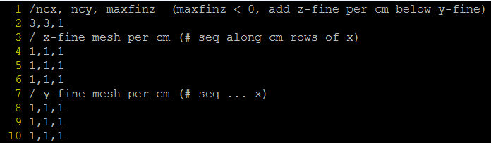

Now we use the option:

Penmshxp –maxmesh 1.0

The result is below: each cell is at most 1.0 cm in size. It sets nmesh=ceiling(CM_size/desired_size).

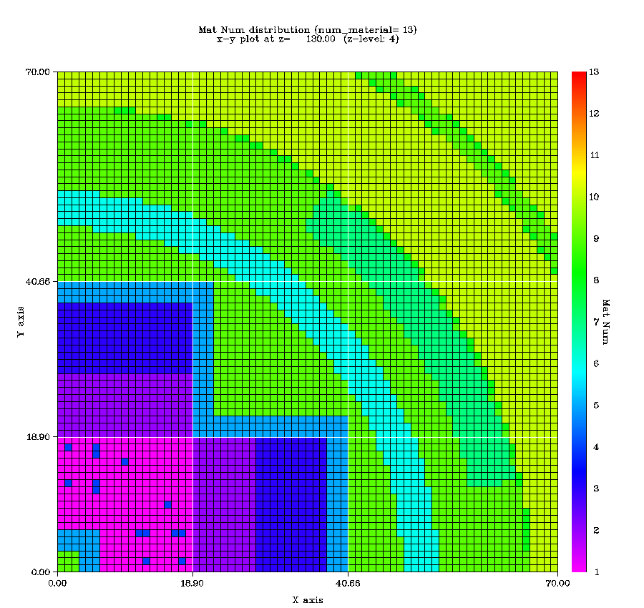

This makes it very easy to change the mesh size without calculating the required number of FM in each CM and editing all of those numbers in every z level file.

Say we want to coarsen the mesh:

Penmshxp –maxmesh 2.0

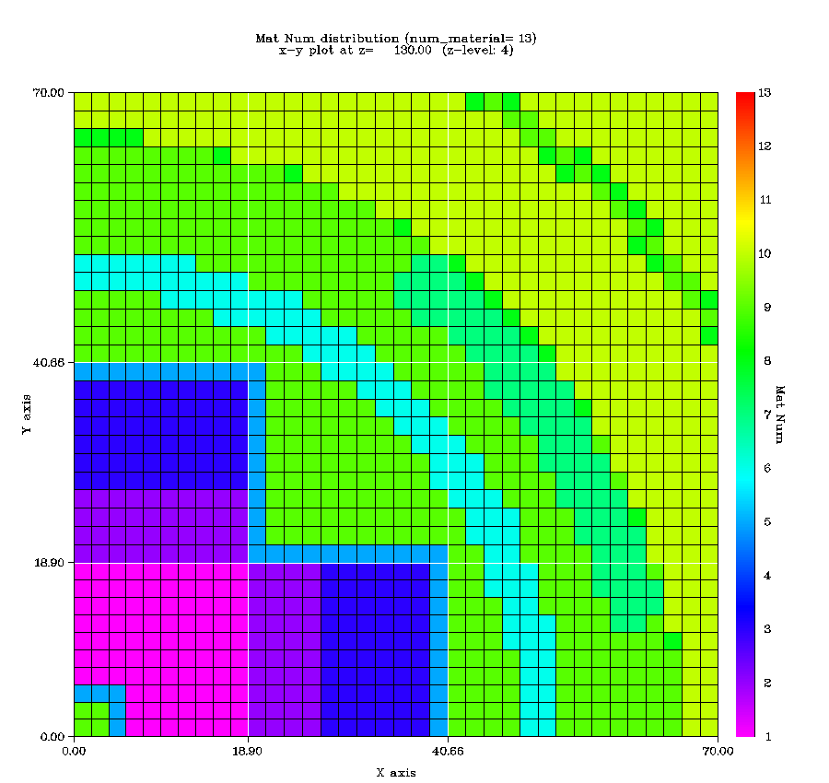

We also allow for non-uniform size meshing in the following way:

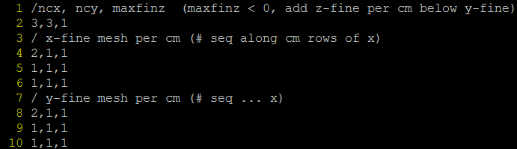

The x and y mesh of CM 1 has been assigned the value 2. These values, instead of being the number of FM, is used as a multiplier for the number of FM. If we use the same command now:

Penmshxp –maxmesh 2.0

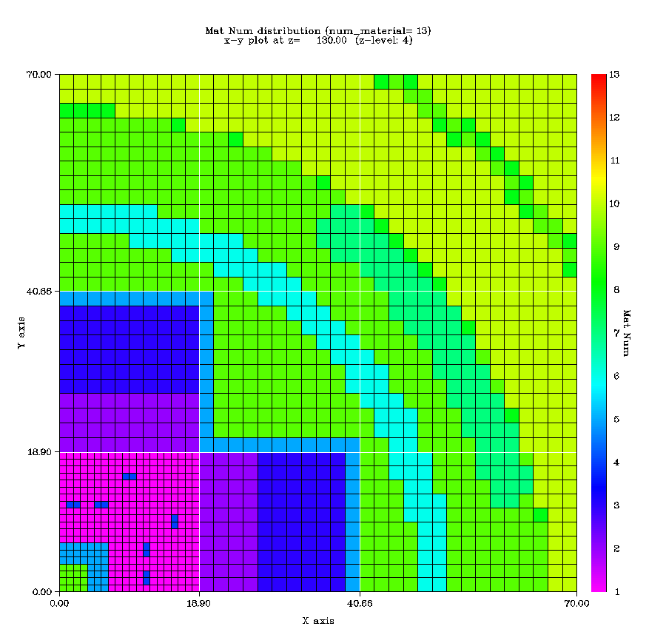

We get double the x and y mesh density for CM 1.